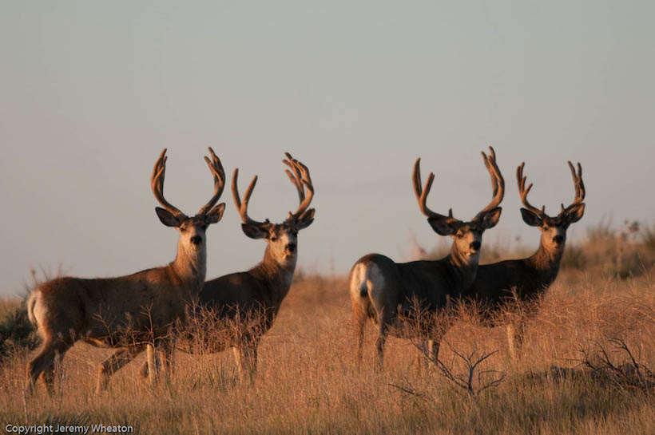  Processing  Cut and Wrapped  Elk, Deer, Antelope (Prong Horn), Moose, Sheep/Goat, Bear, Buffalo  - Carcasses ……………….……$1.45 LB  - Field Boned ……………….…$1.70 LB  - Minimum carcass Fee  - Deer/Antelope ……….....$100.00  - Sheep/Goat ……………..$100.00  - Bear ………………………$100.00  - Elk/Moose ...…………….$300.00  - Buffalo …………..……….$300.00  Additional Services
  Animal | Skinning  NO CAPING | Antler Capped | Teeth  Ivory
  Elk | $50 - Whole  $60 – ½ or ¼ | $20.00 | $10.00
  Deer | $30.00 | $10.00 | NA
  Antelope | $30.00 | $10.00 | NA
  Moose | $55 – Whole  $65 – ½ or ¼ | $20.00 | NA
  Sheep/ Goat | $45.00 | NA | NA
  Bear | $65.00 | NA | NA
  Buffalo | $75.00 | NA | NA
  Important Information
  - “Full cut and wrap” include:
  - loin steak
  - round steak
  - cube steak
  - roast upon request
  - burger with 10% suet
  - suet at or over 20% additional fee
  - All hides belong to Tizer Meats unless buy back is arranged at drop off.
    - Buffalo …………………… $20.00
    - Elk/Moose ……………….. $15.00
    - Deer ……………………… $10.00
    - Antelope …………………... $7.00
  - Antlers/Horns You Want Back
    - Must take horns or head with you at time
  of drop off
  - Beetle Cleaned Orders must be pre-paid and
  skull must be tagged and identified
  - All meat is vacuum sealed
  - Field boned animals are the same price as whole carcass animals
  - No stew meat, liver or heart
  - Thawing fee …………………….. $25.00
  - Excessively dirty ……………..… $20.00
  - Rush Fee:
    - 1-2 days …. …………… double fee
    - 3 days + .…………….....… $100.00
  Effective 10/08/2025
  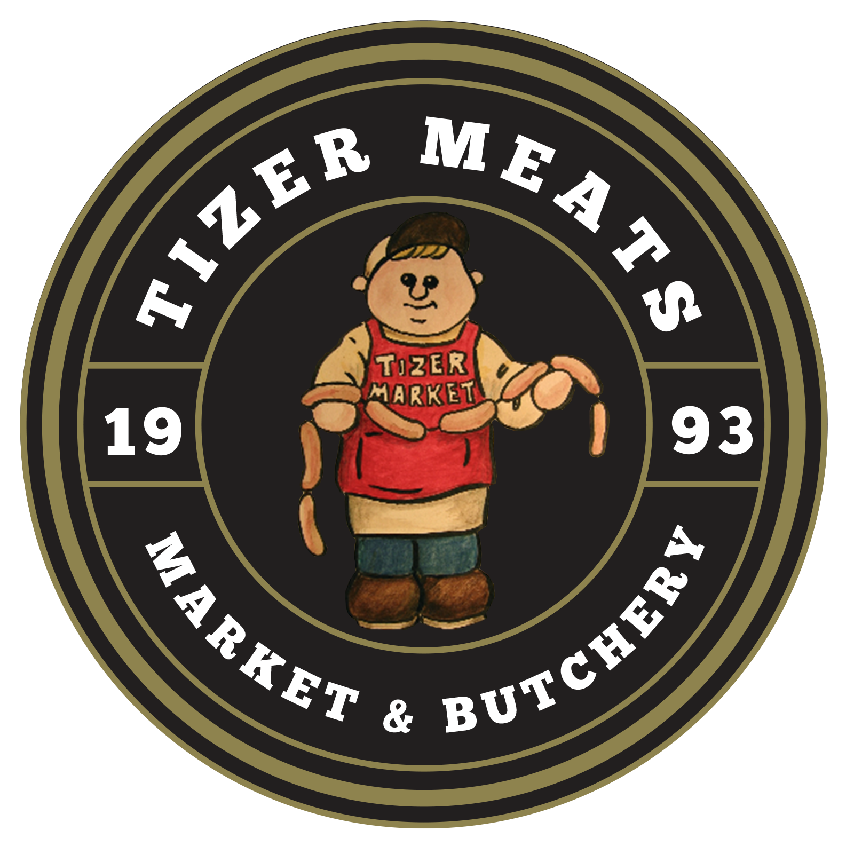 |  | Tizer Meats Wild Game Processing  3558 Tizer Dr  Helena, MT 59602  406-442-3096  www.tizermeats.com
  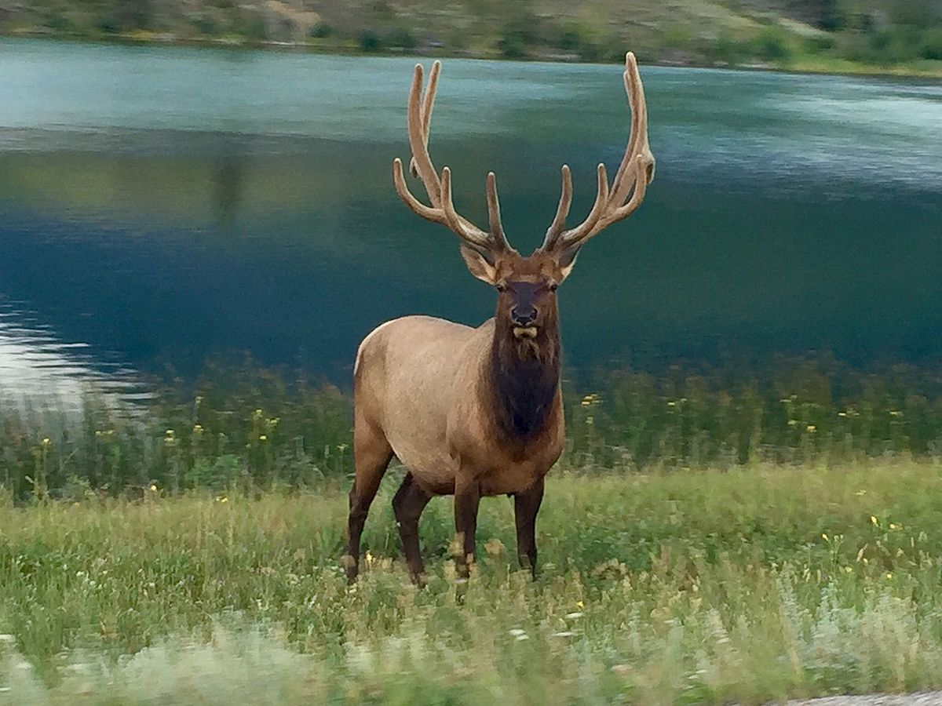
  Effective 10/08/2025
  Tizer Meats Wild Game Processing
    - 3558 Tizer Dr. Helena,
    - MT 59602
    - 406-442-3096
    - www.tizermeats.com

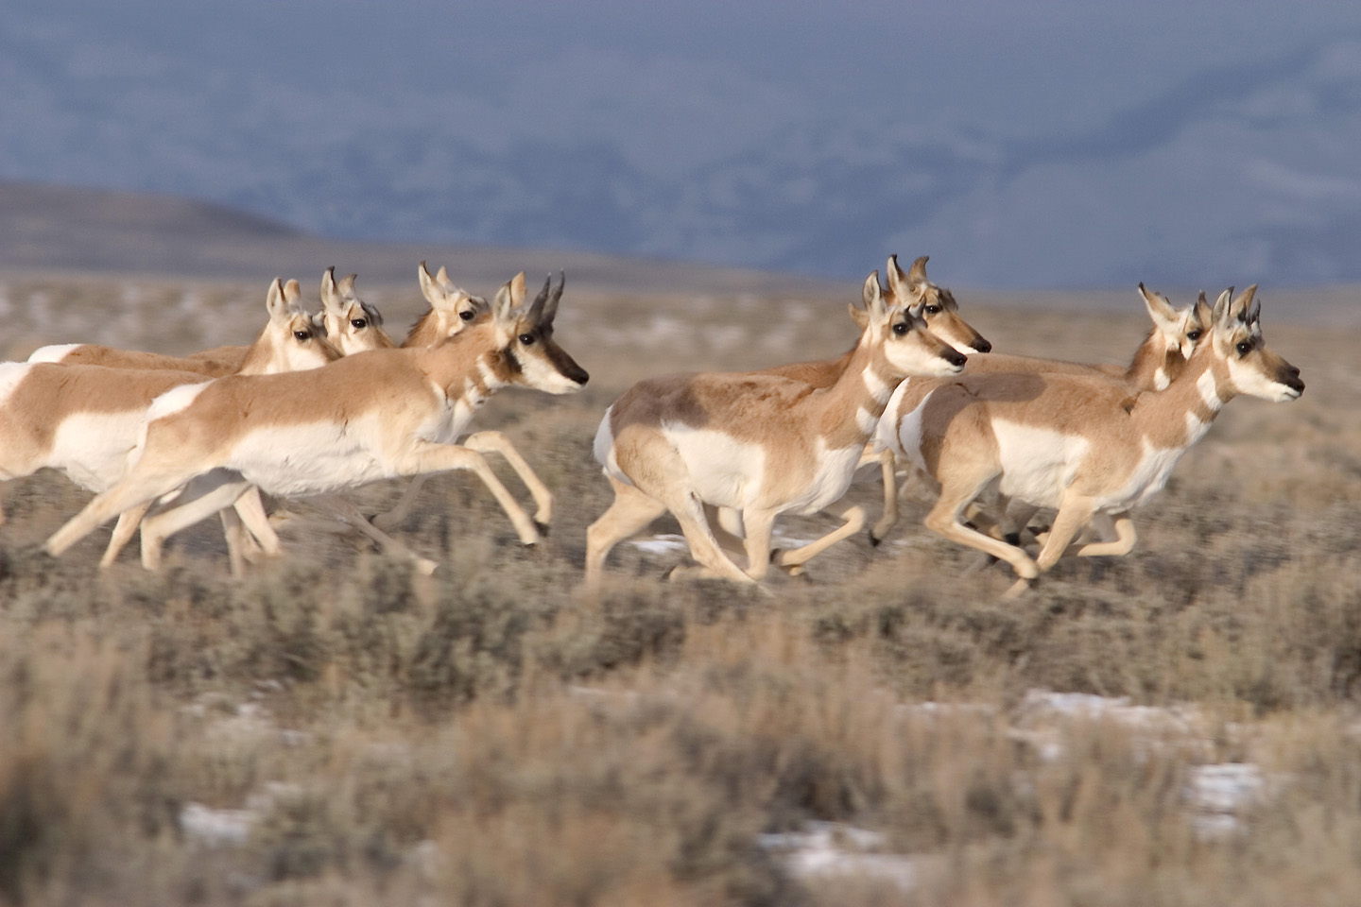  Processing  Bulk Meat (Packaged)  (Clean and ready to process. (Min. Fee $20.00)  - Burger …………………………… $2.50 LB  - Cube Steaks …………………….. $2.00 LB  - Cut Steaks ………………………. $2.00 LB  - Clean up fee ……………………. $2.50 LB  - Custom Smoking  - Smoking …………………… $2.00 LB  - Brining …………….……….. $2.00 LB  - Sliced ……………..………… $2.00 LB  - Packaged …………..………. $1.00 LB  Sausage Making Supplies  - 2.5” Casing …………………………... $1.75  (Holds approx. 3.5 LB)  - Hog Casing ………………………… $10.00  (Holds Approx. 25 LB)  - Bulk Seasoning Available  (Does 25 LB batch) |  |  | SAUSAGE  (Requires 20 LB Raw Meat)  LOGS Per Batch …………………. $130.00  LINKS Per Batch  Smoked …………………… $130.00  Fresh ……………………..…. $95.00  Breakfast Links ………….. $105.00  FRESH BULK Per Batch …………... $75.00  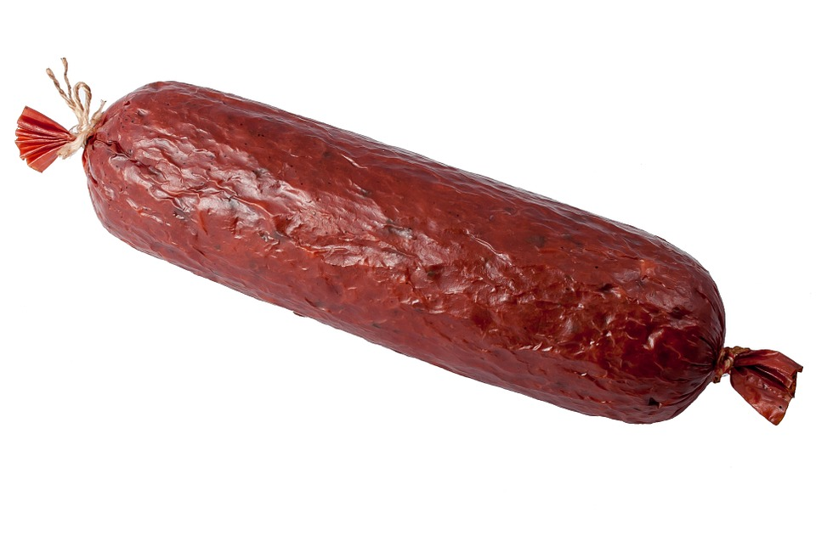 |  |  | 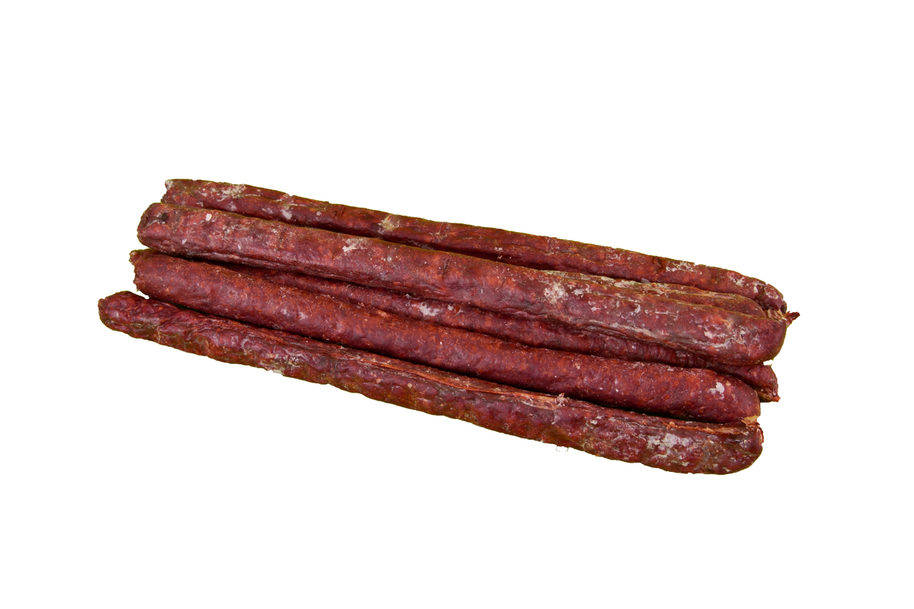  JERKY STICKS  (Requires 25 LB Raw Meat)  Round ………..…………… $140.00  Flat ………..………………. $145.00  (Round is the default shape. You must ask for flat sticks)  Additional Sausage Ingredients  Cheddar Cheese …………… $25.00  Pepper Jack Cheese .………. $30.00  Jalapeno Peppers ……………. $5.00  (Cost per Batch)
  Pastrami | Salami
  Summer | Thuringer
  Bratwurst | Cheddar Dog
  Chili Cheese Dog | Hot Beer
  Sweet Italian | Hot Italian
  Honey Maple | Pepperoni
  Mild German | Spicy German
  Breakfast Links | Polish
  Breakfast | Spicy Breakfast
  Cajun | Chorizo
  Honey Maple | Hot Italian
  Sweet Italian | Mild German
  Spicy German
  Snack | Peppered
  Cajun | Pepperoni

